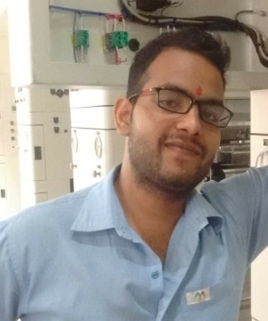

Curriculum-Vitae

Kaushal Kumar Yadav

B.Tech (Electrical Engineering)

Contact No: +919759888847

E-Mail: kaushalana2010@gmail.com

Objectives

I have experience in Electrical functional areas of Printing and Packaging for FMCG, Food & Chemical Industries. To make best use of my skills and strive hard to meet the organization’s expectation levels.

Executive summary

- Handled projects for the company & successfully handled Installing & commissioning of Rotogravure, laminating and Coating machines.
- Experience in the electrical designing, wiring of control panels, PLC and Drives and HMI .
- Maintenance & troubleshooting of Rotogravure Printing, Laminating and Coating machines.
- Exposure to AC drives like PARKER, DELTA, SIEMENS recent drives LIKE AC30, AC10,VFD etc.
- Expertise in various control systems like temperature controller, RTD, THERMOCOUPLE, Pneumatic valve, Motorized valve, Loadcell, relays, MOSFETs etc.
- Basic Exposure to Mechanical assembly & installations.
- Expertise in working in fast-paced and high-tech environments of multinational cultures and countries, requiring skills in planning, Innovative thinking, Project management and Team building.
- Strong Belief and determination to achieve excellent results and desired goals through motivation, inspired commitment, clear communication and demanding top performance.
- Good Communication, interpersonal and negotiation skills.

Experience

Total Work Experience : Around 2+ years.
Area of Experience : Design and Electrical Wiring, Installation, commissioning and maintenance of Rotogravure and Laminating machines.
Montage Enterprises private limited (Uflex Group ), Noida.

It deals in a prominent manufacturer and supplier and import of flexible packaging film, Holographic flexible packaging film, packaging & paper products.

Designation: - OFFICER.
Period: - OCTOBER 2015 to till date

Responsibility

- Designing of main control panels used in various applications like printing machines, lamination machine as well as coating machine.
- Wiring, maintenance & troubleshooting of AC drives like Parker drives & delta and Siemens drives.
- Assisting Printing and allied machines design team to make Panels and electrical transducers positioning.

PROJECT SUMMARY:

- Commissioning of Printing Machine ( ELS )
- Commissioning of Lamination Machine
- Installation of Control Panel for T.P-10 ( Boiler )

Engineering DELIVERABLES – ExPOSURES

- Study of Single line diagrams (SLD) & Elementary diagrams of machines, panels & drives.
- Basic knowledge of Mechanical assembly drawings.
- Good understanding about electrical tools, knowledge in practical as well as theoretical.

Personal Details
Date of Birth : 13th July 1992
Father’s Name : Mr. Mahabal Yadav
Mother’s Name : Mrs. Asarafee Devi

Sex : Male
Marital Status : Unmarried
Nationality : Indian
Permanent Address : Bahadurpur Sirkoni Bazar (222136), Jaunpur
UP.
Languages Known : English and Hindi.

Strengths

Always recognized for outstanding work ethics integrity thoroughness and commitment to organizations benefit, capability to adjust to all kind of situation. Notable interpersonal skills and ability to cultivate positive rapport among friends and colleagues.

DATE:
PLACE:

( KAUSHAL KUMAR YADAV )

